**VOLCKER RULE**

The Volcker Rule is a financial regulation that was part of the Dodd-Frank Wall Street Reform and Consumer Protection Act, enacted in response to the financial crisis of 2007-2008. Named after former Federal Reserve Chairman Paul Volcker, the rule aims to prevent excessive risk-taking by banks.

KEY TAKEAWAYS

* The Volcker Rule prohibits banks from using their own accounts for short-term proprietary trading of securities, derivatives, and commodity futures, as well as options on any of these instruments.
* On June 25, 2020, Federal Deposit Insurance Corp. (FDIC) officials said the agency will loosen the restrictions of the Volcker Rule, allowing banks to more easily make large investments into venture capital and similar funds.
* The main criticism of the Volcker Rule is that it will reduce liquidity due to a reduction in banks’ market-making activities.

1. **Proprietary Trading Ban**:
   * The rule prohibits banks from engaging in proprietary trading, which involves trading stocks, bonds, derivatives, and other financial instruments for the bank's own profit, rather than on behalf of customers.
   * This measure is intended to reduce the risk of significant losses that could jeopardize the financial stability of the bank and, by extension, the financial system.
2. **Restrictions on Ownership Interests in Hedge Funds and Private Equity Funds**:
   * Banks are restricted from owning, sponsoring, or having certain relationships with hedge funds and private equity funds. This is to prevent conflicts of interest and limit the exposure of bank capital to high-risk investment strategies.
3. **Permitted Activities**:
   * The rule allows certain types of trading and investment activities that are considered less risky and essential for the functioning of the financial system. These include:
     + Market making
     + Underwriting
     + Hedging
     + Transactions on behalf of customers
     + Trading in U.S. government, state, and municipal obligations
4. **Compliance and Reporting Requirements**:
   * Banks are required to establish and maintain an internal compliance program to ensure adherence to the Volcker Rule.
   * Large banking entities are subject to more stringent reporting and recordkeeping requirements to demonstrate compliance.

**Impact and Criticisms**

1. **Impact on Banks**:
   * The Volcker Rule has led to significant changes in the operations of major banks, particularly those involved in investment banking. Many banks have scaled back or eliminated their proprietary trading desks.
   * Some banks have also divested their ownership stakes in hedge funds and private equity funds.
2. **Criticisms**:
   * Critics argue that the Volcker Rule is overly complex and has led to increased compliance costs for banks.
   * Some believe that the restrictions on proprietary trading have reduced market liquidity, particularly in the bond markets.
   * Others contend that the rule does not go far enough in preventing risky behaviour by financial institutions.

| **Year** | **Key Developments and Statistics** |
| --- | --- |
| 2018 | **Regulatory Changes**: Congress passed legislation easing Volcker Rule restrictions for smaller banks with less than $10 billion in assets.  **Impact**: Increased flexibility for smaller banks, but ongoing debate about the implications for financial stability. |
| 2019 | **Implementation of Changes**: Federal agencies finalized rule changes exempting community banks from the Volcker Rule, effective January 1, 2020.  **Market Reaction**: Mixed reactions; some banks welcomed the reduced regulatory burden, while others expressed concerns about potential risks. |
| 2020 | **Further Revisions**: Regulators allowed banks to invest in venture capital funds, loosening some restrictions.  **Market Impact**: Increase in venture capital investments by banks; debate about the balance between economic growth and financial risk. |
| 2021 | **Biden Administration**: Signalled intentions to review and potentially tighten Volcker Rule regulations that were loosened during the previous administration.  **Compliance Costs**: Banks reported ongoing compliance costs related to maintaining adherence to the Volcker Rule despite regulatory changes. |
| 2022 | **Market Liquidity**: Studies indicated that the Volcker Rule might have contributed to reduced liquidity in certain markets, such as corporate bonds, due to decreased market-making activities by banks.  **Policy Discussions**: Ongoing discussions about finding a balance between regulation and market efficiency. |
| 2023 | **Future of Regulation**: Continued analysis of the Volcker Rule's impact on market stability and bank behaviour.  **Policy Proposals**: Suggestions for further modifications to enhance regulatory clarity and effectiveness while minimizing negative market impacts. |

This table shows the number of violations related to different types of prohibited trading activities under the Volcker Rule for the years 2020, 2021, and 2022.

|  |  |  |  |
| --- | --- | --- | --- |
| Types of prohibited trading activity | Number of violations in 2020 | Number of violations in 2021 | Number of violations in 2022 |
| Proprietary Trading | 15 | 10 | 5 |
| Investing in Covered Funds | 20 | 18 | 15 |
| Providing Material Assistance | 8 | 6 | 4 |
| Other Violations | 5 | 3 | 2 |

**RETAIL BANKING OPERATIONS**

Retail banking, also known as consumer banking or personal banking, is banking that provides financial services to individual consumers rather than businesses. Retail banking is a way for individual consumers to manage their money, have access to credit, and deposit their funds in a secure manner.

1. **Account Management**:
   * Opening and maintaining checking and savings accounts.
   * Providing statements and managing transactions.
2. **Deposits and Withdrawals**:
   * Handling cash deposits and withdrawals.
   * Offering automated teller machines (ATMs) for easy access to cash.
3. **Loans and Credit**:
   * Offering personal loans, mortgages, auto loans, and credit cards.
   * Assessing creditworthiness and managing loan approvals and repayments.
4. **Customer Service**:
   * Providing assistance with account issues and inquiries.
   * Offering financial advice and support through in-person, phone, and online channels.
5. **Online and Mobile Banking**:
   * Enabling customers to manage their accounts, transfer funds, pay bills, and access other services through digital platforms.
   * Ensuring secure and user-friendly online interfaces.
6. **Payments and Transfers**:
   * Facilitating domestic and international fund transfers.
   * Managing direct debits, standing orders, and other payment mechanisms.
7. **Investment Services**:
   * Providing access to investment products like mutual funds, bonds, and retirement accounts.
   * Offering wealth management and financial planning services.
8. **Fraud Prevention and Security**:
   * Implementing measures to detect and prevent fraudulent activities.
   * Ensuring the security of customer data and transactions.
9. **Compliance and Regulation**:
   * Adhering to banking regulations and ensuring compliance with legal standards.
   * Reporting transactions and maintaining records as required by financial authorities.
10. **Branch Operations**:
    * Managing the physical branches where customers can receive in-person service.
    * Handling cash transactions, account management, and customer inquiries.

A retail bank stores the cash deposits of its retail clients. It then uses these deposits to make loans to other clients. The Federal Reserve formerly required that all banks keep 10% of their demand and checking deposits in-house overnight—this was changed to 0% in March 2020. This is known as the [reserve requirement](https://www.investopedia.com/terms/r/requiredreserves.asp) and is seen as a safety and liquidity measure.

* This table provides a rough idea about the following metrics that might be tracked for retail banking operations:

|  |  |  |  |  |  |
| --- | --- | --- | --- | --- | --- |
| **Metric** | **2019** | **2020** | **2021** | **2022** | **2023** |
| Number of Checking Accounts (millions) | 125 | 130 | 135 | 140 | 145 |
| Number of Savings Accounts (millions) | 95 | 100 | 105 | 110 | 115 |
| Total Deposits (billion USD) | 1500 | 1600 | 1700 | 1800 | 1900 |
| Total Loans Issued (billion USD) | 800 | 850 | 900 | 950 | 1000 |
| Average Interest Rate on Deposits (%) | 1.5 | 1.2 | 1.0 | 0.8 | 0.7 |
| Average Interest Rate on Loans (%) | 4.0 | 3.8 | 3.7 | 3.5 | 3.4 |
| Number of ATMs | 2000000 | 210000 | 220000 | 230000 | 240000 |
| Number of Online Banking Users (millions) | 50 | 55 | 60 | 65 | 70 |
| Number of Mobile Banking Users (millions) | 45 | 50 | 55 | 60 | 65 |
| Number of Fraud Incidents | 10000 | 1200 | 11000 | 9000 | 8000 |
| Total Fraud Losses (million USD) | 500 | 600 | 550 | 450 | 400 |

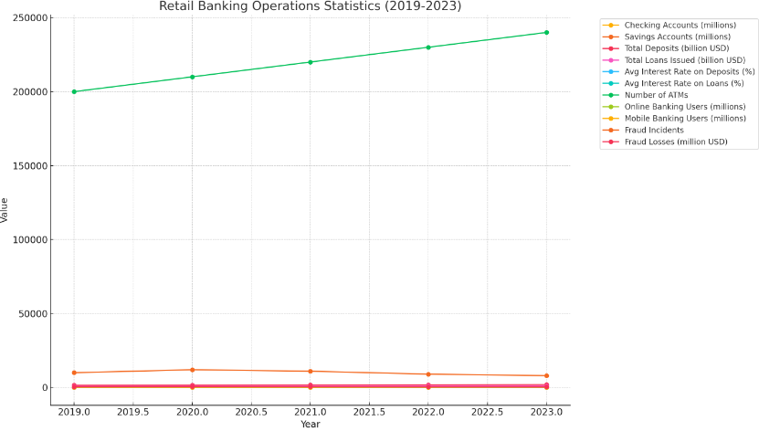

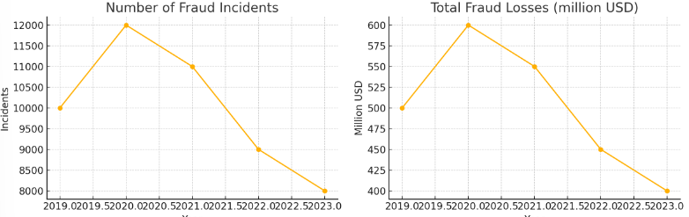

* As of March 31, 2023, the top five largest U.S. commercial banks by assets were:
* JPMorgan Chase
* Bank of America
* Citibank
* Wells Fargo
* U.S. Bank